CS 305 Project One Template

Document Revision History

Version | Date | Author | Comments
1.0 | 09/16/2026 | Emily Beech

Client



Instructions
Submit this completed vulnerability assessment report. Replace the bracketed text with the relevant information. In this report, identify your security vulnerability findings and recommend the next steps to remedy the issues you have found.

- Respond to the five steps outlined below and include your findings.
- Respond using your own words. You may also include images or supporting materials. If you include them, make certain to insert them in the relevant locations in the document.
- Refer to the Project One Guidelines and Rubric for more detailed instructions about each section of the template.

Developer
Emily Beech

1. Interpreting Client Needs
Determine your client’s needs and potential threats and attacks associated with the company’s application and software security requirements. Consider the following questions regarding how companies protect against external threats based on the scenario information:

- What is the value of secure communications to the company?
- Are there any international transactions that the company produces?
- Are there governmental restrictions on secure communications to consider?
- What external threats might be present now and in the immediate future?
- What modernization requirements must be considered, such as the role of open-source libraries and evolving web application technologies?

Artemis Financial needs to protect the information used to create savings, retirement, investment, and insurance plans for its clients. Secure communication is valuable because financial information could be exposed or changed if an attacker intercepts data moving between the client and server. The application should use encrypted connections and protect sensitive information while it is being transmitted and stored.
The scenario does not state that Artemis Financial performs international transactions, so that should not be assumed. It also does not name a specific government restriction that applies to the application. Even so, the company should review any financial, privacy, and data protection requirements that apply to its services before the modernized application is released.
External threats include unauthorized access, stolen customer information, intercepted communications, malicious input, and attacks against outdated software components. The code also relies on open source libraries, which creates another risk when older versions contain known vulnerabilities. Modernization should include supported software versions, regular dependency scans, input validation, access controls, secure error handling, and encrypted communication. These protections need to be reviewed again as the application and its dependencies change.

2. Areas of Security
Refer to the vulnerability assessment process flow diagram. Identify which areas of security apply to Artemis Financial’s software application. Justify your reasoning for why each area is relevant to the software application.

The vulnerability assessment process points to input validation, APIs, cryptography, client and server security, code error handling, code quality, and encapsulation. Each of these areas applies to the Artemis Financial application.
Input validation is relevant because the REST controllers accept values such as name and business_name without visible restrictions on length, format, or content. API security also applies because the application exposes REST endpoints that should only allow appropriate requests and access. Cryptography is important because Artemis Financial handles financial information, and the project includes an old Bouncy Castle cryptography library.
Client and server security matters because the application connects REST clients, the Spring application, and a MySQL database. Error handling is relevant because DocData.java prints SQL exception stack traces. Code quality applies to hardcoded credentials, outdated dependencies, and incomplete methods. Encapsulation also matters because financial data should only be accessible through the parts of the application that need it. Reviewing these areas gives a clearer picture of both code level problems and risks created by the application's dependencies.

3. Manual Review
Continue working through the vulnerability assessment process flow diagram. Identify all vulnerabilities in the code base by manually inspecting the code.

1. Hardcoded database credentials. In DocData.java, the database connection contains the username root and password root directly in the source code. Credentials should be stored outside the source code in protected configuration or environment variables.
2. Excessive database privileges. DocData.java connects with the root database account. The application should use a dedicated account with only the permissions required for its normal database operations.
3. Stack trace exposure. DocData.java calls e.printStackTrace() when a SQL exception occurs. Detailed internal errors should be written to controlled logs while users receive a general error message.
4. Unvalidated business_name input. CRUDController.java accepts the business_name request parameter without visible validation. The application should restrict expected length, format, and allowed content before using request data.
5. Unvalidated name input. GreetingController.java accepts a name value and places it into the response without visible input restrictions. The value should be checked for reasonable length and expected characters before it is processed.
6. No visible authentication or authorization controls. The supplied controllers expose REST endpoints, but the code base does not show authentication or authorization protecting them. Sensitive endpoints should require authenticated users and appropriate permissions.
7. Outdated Spring Boot version. The pom.xml file uses Spring Boot 2.2.4.RELEASE. The dependency scan shows that components brought in by this older framework version have known vulnerabilities. Artemis Financial should migrate to a currently supported Spring Boot release after compatibility testing.
8. Outdated Bouncy Castle library. The pom.xml file uses bcprov-jdk15on version 1.46. The dependency check identified known vulnerabilities in this version, including a cryptographic signature verification issue. The library should be upgraded to a supported version after testing.
9. Weak encapsulation of account data. In customer.java, account_balance is not declared private. Financial fields should be private and accessed through controlled methods so other classes cannot change them directly.
10. Deposit values are not validated. The deposit method in customer.java adds any integer to the balance, including a negative value, and does not check for arithmetic limits. The method should reject invalid amounts and use a safer representation for financial values.

4. Static Testing
Run a dependency check on Artemis Financial’s software application to identify all security vulnerabilities in the code. Record the output from the dependency-check report. Include the following items:

- The names or vulnerability codes of the known vulnerabilities
- A brief description and recommended solutions provided by the dependency-check report
- Any attribution that documents how this vulnerability has been identified or documented previously

The OWASP Dependency Check scan used version 12.1.0. It scanned 38 dependencies, found 13 vulnerable dependencies, and reported 293 vulnerabilities. The generated report identified problems in Bouncy Castle, Hibernate Validator, Jackson Databind, Log4j, Logback, SnakeYAML, Spring Boot, Spring Framework, and Tomcat components. The Sonatype OSS Index portion returned an authentication error, but the NVD data update completed and the HTML vulnerability report was generated.
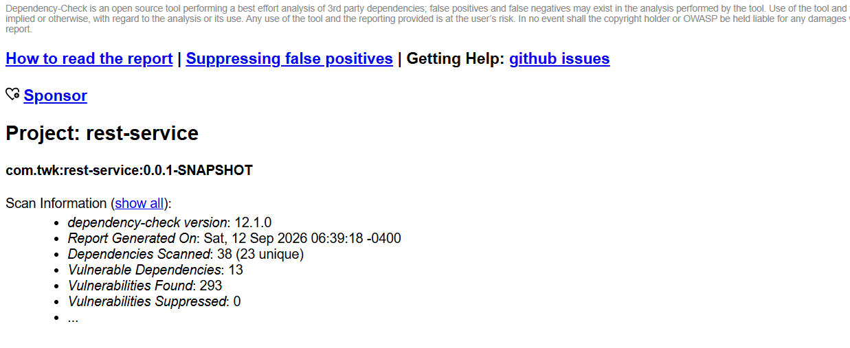
CVE 2016 1000338, Bouncy Castle 1.46
The report rated this vulnerability High with a CVSS v3 score of 7.5 and identified CWE 347, Improper Verification of Cryptographic Signature. Bouncy Castle JCE Provider 1.55 and earlier does not fully validate the ASN.1 encoding of DSA signatures. Extra elements can be inserted while a signature still validates in some cases. Because the project uses Bouncy Castle 1.46, the dependency falls within the affected versions. The recommended response is to replace the outdated library with a supported version that is not affected by the vulnerability. The dependency check report documents the issue through the NVD CVE record and linked third party advisories.
CVE 2022 22965, Spring Framework 5.2.3.RELEASE
The report rated this vulnerability Critical with a CVSS v3 score of 9.8 and identified CWE 94, Improper Control of Generation of Code. Under specific conditions, a Spring MVC or Spring WebFlux application running on JDK 9 or later can be vulnerable to remote code execution through data binding. The report also notes that the known exploit requires particular deployment conditions and that the default Spring Boot executable JAR is not vulnerable through that exact path. The finding should still be addressed because the project uses an outdated Spring Framework version. The recommended response is to update Spring according to vendor guidance. The report identifies this CVE as a CISA Known Exploited Vulnerability and also references the NVD record.
CVE 2022 1471, SnakeYAML 1.25
The report rated this vulnerability Critical with a CVSS v3 score of 9.8 and identified CWE 502, Deserialization of Untrusted Data, and CWE 20, Improper Input Validation. SnakeYAML's Constructor class can instantiate unrestricted types during deserialization, so attacker controlled YAML content can lead to remote code execution. The report recommends using SafeConstructor when parsing untrusted content and upgrading to SnakeYAML 2.0 or later. The project contains SnakeYAML 1.25, so this dependency should be updated. The dependency check report documents the issue through the CVE record and related security advisories.

5. Mitigation Plan
Interpret the results from the manual review and static testing report. Then identify the steps to mitigate the identified security vulnerabilities for Artemis Financial’s software application.

The first priority is to remove the hardcoded database username and password from DocData.java and replace the root account with a dedicated database account that has only the permissions the application needs. SQL exceptions should also be handled through controlled logging instead of printing full stack traces. These changes reduce the chance that credentials or internal application details are exposed.
The REST endpoints should validate request values before processing them. Limits should be placed on the length and expected format of name and business_name. Authentication and authorization should be added for any endpoint that accesses protected financial information. Account data should be private, and methods that change balances should reject negative or otherwise invalid amounts. Financial calculations should use a representation designed to avoid unsafe integer behavior.
The dependency findings require updates as part of the modernization work. Bouncy Castle 1.46 should be replaced with a supported release that addresses the cryptographic signature issue. Spring Boot and its Spring Framework dependencies should be migrated to supported versions after compatibility testing. SnakeYAML should be upgraded to version 2.0 or later, and SafeConstructor should be used if the application parses untrusted YAML. The remaining vulnerable dependencies identified in the report, including Jackson, Log4j, Logback, Hibernate Validator, and Tomcat, should also be reviewed and updated through supported framework versions rather than ignored individually.
After the changes are made, the team should run the dependency check again and repeat the manual review. Any new dependency should be reviewed before it is added to the project, and dependency scanning should be repeated during future updates. This gives Artemis Financial a way to address the current findings while continuing to catch vulnerabilities as the application changes.

